Difference between ArrayList and Vector

ArrayList and Vector both implements List interface and maintains insertion order.

However, there are many differences between ArrayList and Vector classes that are given below.

|  |  |
| --- | --- |
| **ArrayList** | **Vector** |
| 1) ArrayList is **not synchronized**. | Vector is **synchronized**. |
| 2) ArrayList **increments 50%** of current array size if the number of elements exceeds from its capacity. | Vector **increments 100%** means doubles the  array size if the total number of elements exceeds  than its capacity. |
| 3) ArrayList is **not a legacy** class. It is introduced in JDK 1.2. | Vector is a **legacy** class. |
| 4) ArrayList is **fast** because it is non-synchronized. | Vector is **slow** because it is synchronized, i.e., in a  multithreading environment, it holds the other threads  in runnable or non-runnable state until current thread  releases the lock of the object. |
| 5) ArrayList uses the **Iterator** interface to traverse the elements. | A Vector can use the **Iterator** interface or  **Enumeration** interface to traverse the elements. |

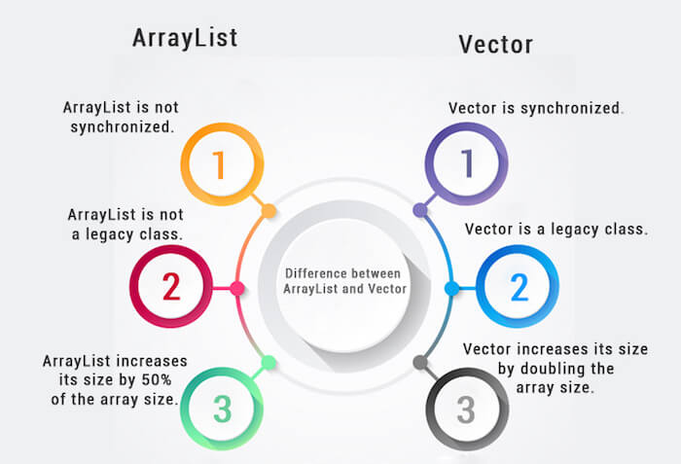

Example of Java ArrayList

Let's see a simple example where we are using ArrayList to store and traverse the elements.

1. **import** java.util.\*;
2. **class** TestArrayList21{
3. **public** **static** **void** main(String args[]){
5. List<String> al=**new** ArrayList<String>();//creating arraylist
6. al.add("Sonoo");//adding object in arraylist
7. al.add("Michael");
8. al.add("James");
9. al.add("Andy");
10. //traversing elements using Iterator
11. Iterator itr=al.iterator();
12. **while**(itr.hasNext()){
13. System.out.println(itr.next());
14. }
15. }
16. }

**[Test it Now](http://www.javatpoint.com/opr/test.jsp?filename=TestArrayList21" \t "_blank)**

Output:

Sonoo

Michael

James

Andy

Example of Java Vector

Let's see a simple example of a Java Vector class that uses the Enumeration interface.

1. **import** java.util.\*;
2. **class** TestVector1{
3. **public** **static** **void** main(String args[]){
4. Vector<String> v=**new** Vector<String>();//creating vector
5. v.add("umesh");//method of Collection
6. v.addElement("irfan");//method of Vector
7. v.addElement("kumar");
8. //traversing elements using Enumeration
9. Enumeration e=v.elements();
10. **while**(e.hasMoreElements()){
11. System.out.println(e.nextElement());
12. }
13. }
14. }

**[Test it Now](http://www.javatpoint.com/opr/test.jsp?filename=TestVector1" \t "_blank)**

Output:

umesh

irfan

kumar